Business Updates | 2017

August 22, 2017

The News Release in this Business Update was disseminated internationally today.

El Capitan Reports First Revenues from Precious Metals Sales

and Pilot Scalability Plan for 2017

Scottsdale, Arizona – El Capitan Precious Metals, Inc. (OTC/QB: ECPN) confirms that it received its first payment on the sale of precious metals extracted from El Capitan ore in June of this year from a domestic precious metals refinery. The Company has since dispatched a second shipment of precious metal alloy bars to the refinery for processing and payment.
According to John F Stapleton, Chairman and CEO, the first shipment—weighing slightly over four pounds—was a key step in establishing protocols and procedures that will be implemented in future, larger translations. The second shipment of precious metal alloy bars had a total weight of approximately 13.5 pounds, or about three times the weight of the first shipment.
From the first alloy bar shipment, the refinery recovered gold, silver, and platinum, which represented approximately six percent of the total weight of the bar. For these precious metals, El Capitan was paid approximately $3,600, or approximately $900 for each pound of the concentrated metal alloy. Stapleton stresses that it is important to note that the bar also contained iridium and osmium and that, on the first shipment, the Company was not paid for the iridium and the osmium. That is expected to change, he stated, related to future shipments on which the refiner would pay for all precious metals in the alloy bars.
The Company estimates that, if it has been paid for the iridium and osmium metals in the first shipment, the percent of total weight subject to payment would have been 10 percent (versus six) with an added payment of $1,400, bringing the total payment to approximately $5,000.
“The bottom line,” said Stapleton,” is that the financial elements of the initial transaction calculate to and demonstrate that, had El Capitan been paid for all the precious metals in the bar, it would have received approximately $1,250 for each pound of precious metals concentrates that it produced and sold.”
Based upon one ton of precious metals concentrates, which would weigh 2,000 pounds, this would calculate to a payment of approximately $2,500,000.
Stapleton added that, while the Company, under contact terms, has not yet received payment on the second shipment of alloy bars, it has been informed that it will receive payment for all precious metals—gold, silver, platinum, iridium, and osmium—in the metal alloy bars in the second transaction and in subsequent shipments.
The Company expects its third shipment to be approximately 500 pounds of precious metals concentrates and that material is being prepared for shipment.
Stapleton stressed that in developing new methods of extracting precious metals, the process requires that the Company start with a small run which would increase incrementally with each successive run and shipment, assuring that the process and results remain consistent with increasingly large amounts of material or, alternatively, making the necessary adjustments. “That is exactly the purpose of a Pilot Operation,” said Stapleton, “and the incremental ramp up has proven to be successful.”
As announced at the July Shareholders’ Informational Meeting, once the larger shipments consistently prove to produce the same level of results, El Capitan expects to arrange for its ore to be concentrated and its precious metals to be recovered in much larger quantities in a Production Operation. Planning and discussions are already taking place to support this transition.
Company management is very confident of the attractiveness of these recovery methods, their cost-effectiveness, and their scalability.

August 8, 2017

El Capitan Announces

July Sales and Shipments of Precious Metals

Scottsdale, Arizona – El Capitan Precious Metals, Inc. (OTC/QB: ECPN) announced today that in the month of July it has shipped a total of 13.5875 pounds of El Capitan precious metals recovered from its El Capitan mine site to a U.S.-based refinery. August shipments are on schedule and the Company will report both the recovery details as well as the dollar value of July shipments within the next 45 days.
According to John F Stapleton, Chairman and CEO, revenue from the initial June shipment will be realized in the quarter ending June 30, 2017 and the Company will continue to process precious metals from its concentrates.
As reported at the July 26, 2017 Shareholders’ Informational Meeting, the Company continues work in anticipation of additional mining and transport work later this year. Road improvements to support future needs and plans as well as agreements with the U.S. Forest Service are in progress and work on installation of the Jersey barriers has been completed. Roadwork in progress: work on Jersey barriers completed.
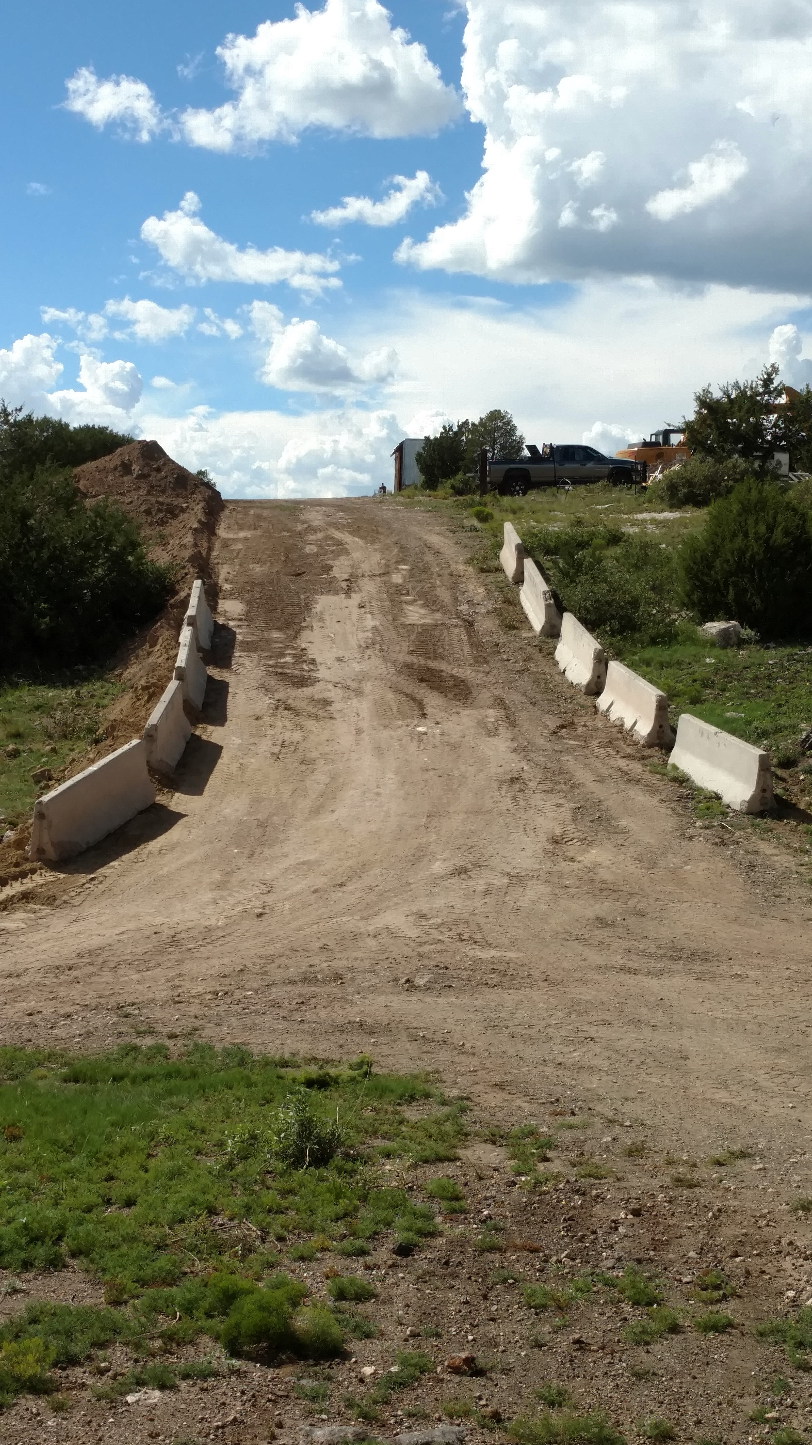
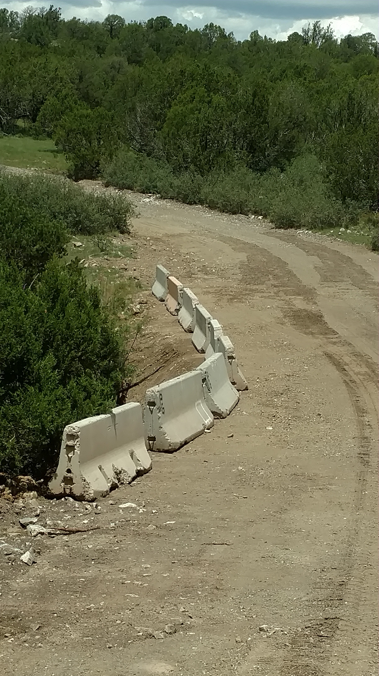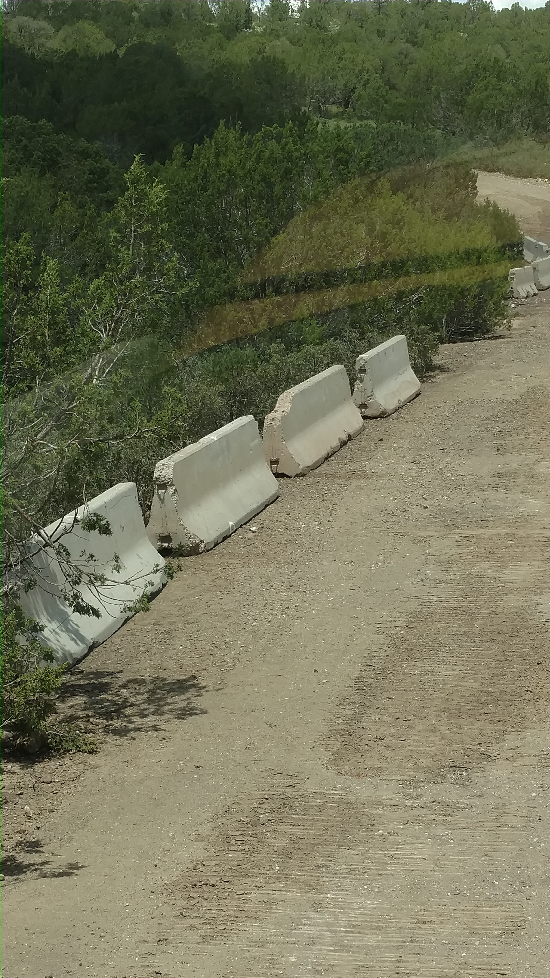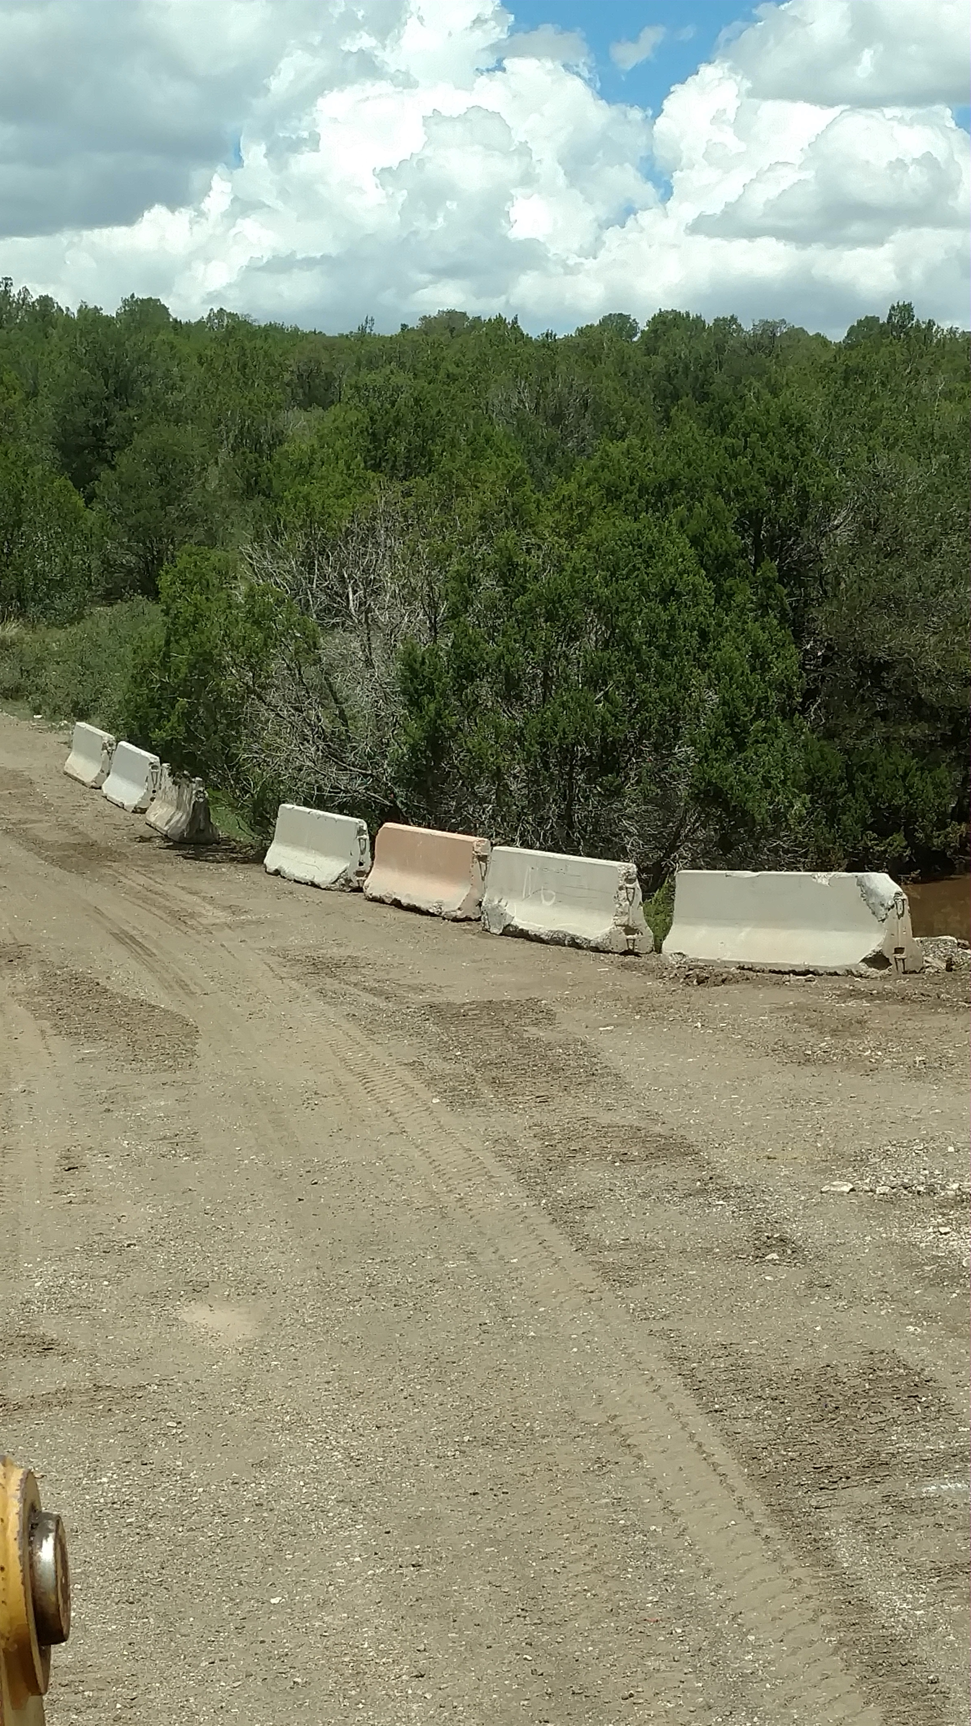

July 26, 2017

A Shareholders’ Informational Meeting is being held today in Scottsdale, Arizona.

Here is a link to the information that will be presented:

LINK TO PowerPower Presentation

The meeting will be recorded and the audio file will post here as soon as it is

available:

LINK TO AUDIO of Shareholders’ Informational Meeting

July 17, 2017

The News Release in this Business Update was disseminated internationally today.

El Capitan Realizes First-Ever

Revenue from Sale of Precious Metals

Scottsdale, Arizona – In a historic milestone, El Capitan Precious Metals, Inc. (OTC/QB: ECPN) announced today that its first-ever payment on the sale of precious metals recovered from its El Capitan mine site has been issued to the Company. The payment is for the initial shipment of precious metals pursuant to a recently-announced contract with a U.S.-based refinery.
According to John F Stapleton, Chairman and CEO, this initial transaction established the procedures and protocol for future shipments and payments that will continue throughout the year. Revenue from the initial shipment will be realized in the quarter ending June 30, 2017.
The metal bar shipped to the refinery was found to contain the following elements by weight: Gold 65% Platinum 15% Silver 20%
The Company also announced that, in addition to this first payment, it has sent a second shipment of larger quantity in the form of precious metals bars to the same refinery for processing, The Company will continue to process precious metals concentrates from its ore and expects each successive shipment to be larger in size until maximum capacity for the pilot plant is reached.
Stapleton reported that management is very enthusiastic about the Company becoming a revenue-generating mining operation, having transitioned from an exploration company less than one year ago.
A description of the major steps in this process will be the focus of the July 26, 2017 Shareholders’ Informational Meeting scheduled to begin at 10:00 a.m. at the Gainey Ranch Golf Club in Scottsdale, Arizona.

July 6, 2017

The News Release in this Business Update was disseminated internationally today.

El Capitan Announces Executed Agreement

for Sale of Precious Metals

Scottsdale, Arizona – El Capitan Precious Metals, Inc., (OTC/QB: ECPN) announced today that it has executed an agreement for the sale of precious metals to a U.S.-based refinery through the Canada-based metals broker PFL Bullion Consultants. The one-year contract, against which the Company has already completed the first shipment, is already in effect awaiting final assays and payment.
This news comes on the heels of the Company’s June report that smelting and the production of precious metals in alloy form validated the precious metals content of its concentrates as well as the precious metals recovery process.

The Company also announced details on an Informational Meeting for Shareholders slated for Wednesday, July 26, 2017. The meeting will be held at the Gainey Ranch Golf Club in Scottsdale, Arizona and is scheduled to begin at 10 am. Board Chairman John F Stapleton stated that the agenda for the Informational Meeting will include:

• an update on regulatory activities, including the agreement with the U.S. Forest Service

• an overview of the creation of the pilot processing plant

• operational details related to the pilot plan as an interim processing facility

• details on the smelting of concentrates into saleable metal

• a recap of the sale of El Capitan precious metals under the agreement with PFL Bullion Consultants

• a financial report from the quarter closing June 30th

June 30, 2017

SHAREHOLDER INFORMATIONAL MEETING SCHEDULED

DATE: Wednesday, July 26, 2017

TIME: 10 am to 12 noon

PLACE: Gainey Ranch Golf Club

7600 Gainey Club Drive | Scottsdale, Arizona

June 8, 2017

The News Release in this Business Update was disseminated internationally today.

Recovery Demonstrations Prove Values of El Capitan Ore

to Satisfy World-Class Refineries

Scottsdale, Arizona – El Capitan Precious Metals, Inc., (OTC/QB: ECPN) announced today that it has successfully conducted smelting demonstrations, with refinery representatives present, of its concentrates to produce precious metals in alloy form—and prove the precious metals content of its concentrates. The Company commissioned this work to support negotiations with three refiners, two of which rank among the top precious metals refiners in the world. The initial shipment to one of the three companies was completed today.
This proves—validates—both the precious metals recovery process and the precious metals values from concentrates.
The Company plans to hold an Informational Meeting for Shareholders in late July to provide a complete description of the process as well as the metallurgical results, sales updates, and future contract commitments that have resulted from this work. Details on that meeting will be announced by the end of June.

February 27, 2017

The News Release in this Business Update was disseminated internationally today.

U.S. Forest Service Agrees to Right of Way Road Use

at El Capitan Mine Site

Scottsdale, Arizona – El Capitan Precious Metals, Inc., (OTC/QB: ECPN) announced today that the U.S. Forest Service has agreed to El Capitan’s use of Right of Way road access at its New Mexico mine site. The agreement represents the Company’s ability to overcome yet another obstacle on its path toward supporting its mining operations and revenue generation.

John F Stapleton, Chairman and CEO, stressed the importance of the Forest Service agreement for the Company’s ability to support its full range of operational activities—from mining to crushing ore at the mine site. The Company is able to operate at a full commercial level. As reported last week, the equipment for the processing plant is on site, installation is in progress, and the plant is expected to be operational within the next week.

Stapleton added, “The agreement to the Right of Way resolution from the Forest Service is the result of months of meetings and discussions with state and national agencies and persistent due-diligence work and follow-through by El Capitan and its advisors.”
The Company anticipates several key announcements and updates in the coming weeks, all of which will move forward its agenda for revenue generation and enhancement of the asset value of the New Mexico property.

TO SEE THE ENTIRE AGREEMENT WITH THE U.S. FOREST SERVICE go to INVESTOR INFORMATION Documents… or click here

February 21, 2017

The News Release in this Business Update was disseminated internationally today.

El Capitan Precious Metals Pilot Plant Operations Move Forward

Delivery of AuraSource II Equipment Confirmed and Installation in Progress

as Company Prepares Concentrates for Sale

Scottsdale, Arizona – El Capitan Precious Metals, Inc., (OTC/QB: ECPN) announced today that the AuraSource II machine that will process its concentrates for sale directly to refiners has arrived at the pilot plan site and will be operational by the end of February. Imported from China, the multi-million-dollar, proprietary technology of this device was specifically designed and calibrated for the final processing of El Capitan concentrates and is uniquely suited for the recovery of precious metals from the El Capitan ore.
According to John F. Stapleton, Chairman and CEO, the pilot processing plant operations represent the central resource in the Company’s ability to take its precious metals to market. “It’s very encouraging to be bringing the new processing plant on line giving us control over the final step in processing the El Capitan concentrates for sale.”
Stapleton added that the Company anticipates several key announcements and updates over the coming weeks, all of which will move forward its agenda for revenue generation and enhancement of the asset value of the New Mexico property.

